In continuation of my previous bonus project (geo-visualization), in this project, I am extending that project by adding the element of time. What I am doing in this project is visualizing 1996 segments of Interstate 77 and Interstate 81 in the state of Virginia, shown in the below map.

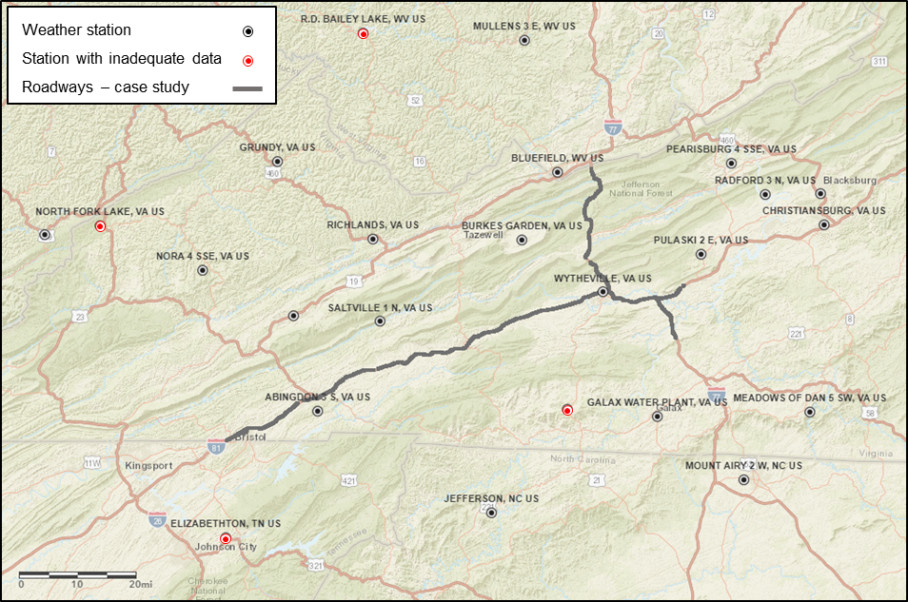

I have a dataset that has recorded the maximum temperature recorded in multiple weather stations in the vicinity of this location. Then, I interpolated the maximum temperature and created a dataset that contains the maximum temperature recorded on each segment at 2014, 2015, 2016, 2017, and 2018. I have the latitude and longitude of each segment as well. Then, what I do here is creating a cube of time-space with visualizing the location of each segment on the bottom and the maximum temperature recorded in different years stacked on their location as shown below:

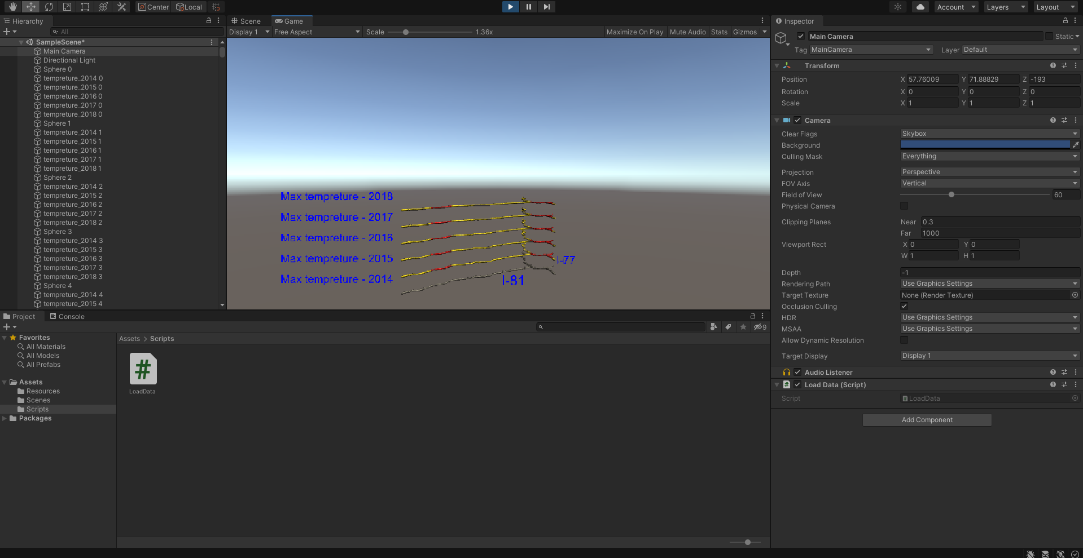

The color coding that I use is below:

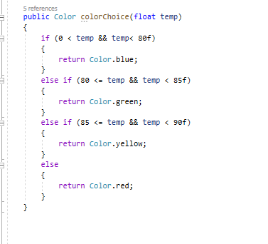

According to my graph, it can be concluded that the maximum temperature recorded in the segments does not vary given our color-coding scheme in 5 years.